Note: This document is “view only”. Please create a copy of this document and save it to your drive.

**SOP- Setting Up Email Forwarding - Systems Vault**

**PREREQUISITES**

[Master: SOP- Staff Leave- Systems Vault](https://docs.google.com/document/d/1YPqCJZGbZCYOSZIuZasErqMDSNA0Z3S2gq1Iib8w-20/edit?usp=sharing)

Gmail and login details for both accounts

**PURPOSE**To set up forwarding from one gmail email account to another.

**POLICY**

Email forwarding is set up when a staff member goes on holiday or temporary leave. We also set up email forwarding when a client sets up an email address for us and we want it forwarding to one general inbox (instead of having to check multiple).

**PARTY**All Team Members

**PROPERTY**

Operations Manager

**PROCESS**

Part 1: Enable forwarding in the account that you want to add to your existing account

Part 2: Login to the account that you want to use as the primary account and add the secondary account

**PROCEDURE**

**Part 1: Enable forwarding in the account that you want to add to your existing account**

1. In the top right, click Settings Settings.
2. Click Settings.
3. Click the Forwarding and POP/IMAP tab.
4. In the "Forwarding" section, click Add a forwarding address.
5. Enter the email address you want to forward messages to.
6. Click Next and then Proceed and then OK.
7. A verification message will be sent to that address. Click the verification link in that message.
8. Go back to the settings page for the Gmail account you want to forward messages from, and refresh your browser.
9. Select Forward a copy of incoming mail to.
10. Choose what you want to happen with the Gmail copy of your emails- archive.
11. At the bottom of the page, click Save Changes.

**Part 2: Login to the account that you want to use as the primary account and add the secondary account**

1. Sign in to your Google Apps email.
2. Click the  in the upper-right and select Settings along the top of any page, and select the [Accounts](http://mail.google.com/mail/#settings/accounts) tab.
3. Under Send mail as, click Add another email address.
4. Enter your name and alternate email address.
5. Unclick “Treat as an alias”
6. Click Next Step >> and then click Send Verification. Gmail will send a verification message to your other email address to confirm that you own it.
7. Locate the message from Gmail. Open it and and either click the link contained in the message or enter the confirmation code in the Accounts section of your Google Apps email settings.

**Important** If you get a warning such as:

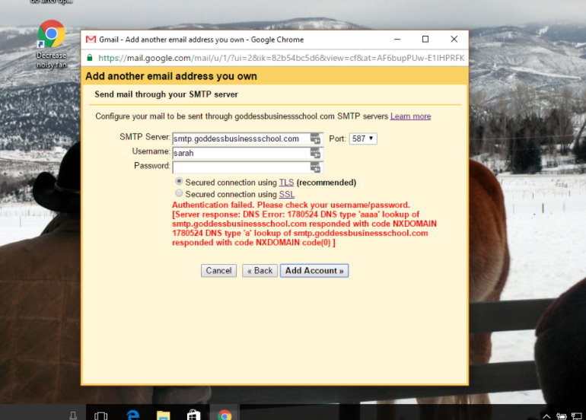

Make sure that your settings are correct:

SMTP Server= stmp.gmail.com

Username = FULL email address that you was to reply as from

Password = the one you use to access the account

If nothing else works:

1. Login to the account that you are ADDING and update the account access for less secure apps
   1. ["Less secure apps" section](http://www.google.com/settings/security/lesssecureapps)
   2. Next to "Access for less secure apps," select Turn on.
   3. Note: This setting is hidden if the administrator has locked less secure app account access

**Created by:**

**Department:** Operations & Support

**Date:**

**Revised:**

**Revised by:**